What is the aim of the Network Meetings?
Meetings take place every 6 weeks, with separate meetings in the North, South and City areas. They aim to:
- Discuss specific children to make sure they are being kept safe, and review progress.
- Identify underlying issues that may make a child vulnerable to exploitation.
- Share information to get a full picture of any exploitation risk and use different strategies to reduce incidents.
- Identify further support available from schools, charities and the voluntary sector.
- Share best practice between professionals.
- Discussion at this meeting does not constitute a referral to Children’s Social Care

How will my family’s information be used?
Discussions from the meeting will be kept confidential by all members.
Minutes from the meeting will be distributed to relevant professionals. This ensures everyone knows what actions they need to take following the meeting.
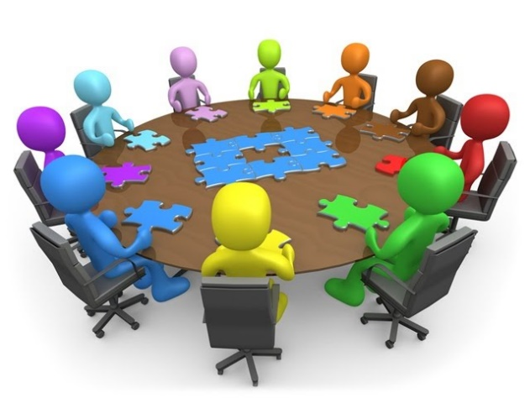

If your child is being discussed at a meeting, the completed Exploitation Screening Tool will be sent to LCSS ahead of the meeting.
Information should only be shared with your consent. However, there are certain times when professionals need to share information, for example to safeguard a child who is at risk of significant harm.

Children at Risk of Exploitation Network Meeting
A Guide for Families

Introduction
The Children at Risk of Exploitation Network Meeting is facilitated by Oxfordshire County Council’s Children’s Services.

This meeting helps professionals to collaborate and offer joint up support to children and young people who are at risk of exploitation.

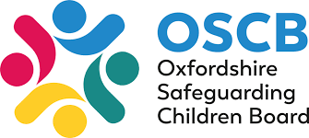

Right support at the right time for Oxfordshire’s Children and families

How do professionals identify a risk of exploitation?
There can be lots of different signs that a child is at risk of exploitation, and these are easy to miss when people don’t have the whole picture.
If they are concerned, professionals may complete the Exploitation Screening Tool with your child. This tool is designed to get a comprehensive view of your child’s situation.
This screening tool will always be completed before the child can be considered for discussion at a Network Meeting. If an immediate risk is identified in this tool, professionals must instead send it to the multi-agency safeguarding hub (MASH). This lets them investigate and make sure your child is kept safe.

Will my child be discussed in a Network Meeting?
The Children at Risk of Exploitation Network Meeting is only used to discuss children who do not have involvement with statutory children’s services (and their siblings do not have any involvement).
If a someone would like to discuss your child at a meeting, they will always ask you first. Your child will only be discussed with your consent.

How can these meetings help my family?
If your child is at risk of exploitation, a professional can bring their concerns to the Children at Risk of Exploitation Network Meeting to help find ways to support your child and keep them safe.
This meeting is an opportunity for people to communicate and work together. Some of the benefits for your family include:

- Professionals collaborating to keep your child safe at school and in the community.
- Building up a full picture of your child’s situation, in order to prevent exploitation.
- Identifying support available for your child from school, charities and voluntary sector organisations.
- Feedback for your family outlining the discussion of your child in the meeting.

Who will be there?
The meetings are chaired by an Assistant Team Manager from the Locality and Community Support Service (LCSS).
This meeting is an opportunity for different agencies to work together and co-ordinate the support they are providing.
Representatives from the following areas are invited to the meeting:

- OCC Family Solutions - Early Help Team
- Sexual Violence and Exploitation Network
- School Health Nurses
- Child and Adolescent Mental Health Services
- School/college designated safeguarding leads
- Thames Valley Police
- District Council
- Voluntary Sector Organisations

