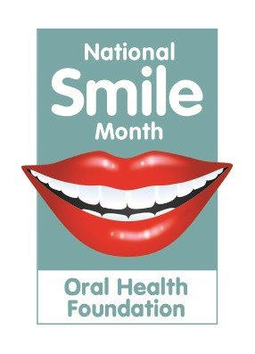
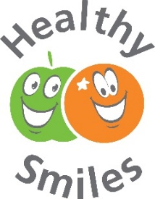
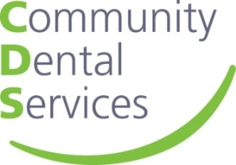

Toothy Tips:

- Milk and still, unflavoured water are the only tooth-friendly drinks. All other drinks can contribute to tooth decay and tooth erosion.

- Use family toothpaste which contains fluoride; this will help strengthen tooth enamel(the strong outer part of the tooth) to help prevent tooth decay.

- After brushing teeth (you and your children) should avoid rinsing out with water or mouthwash – you will wash the fluoride in the toothpaste away! Just spit out the excess foam – job done!

- Don’t add sugar to drinks and food given to babies and children.

- Babies/children who cannot spit out after brushing should have just a smear of family toothpaste on their brush.

- Whitening toothpaste is not suitable for children 12 years and younger.

- Often there are sugar-free medications available instead of sugary ones. Choose these, where possible, and you will reduce the amount of sugar coming into contact with teeth.

- Brush twice a day for two minutes. Brushing before bedtime is very important – make sure you don’t eat or drink anything after, unless it is plain water.

- Supervise brushing teeth and gums until children are 8 years old; they need help to brush their back teeth.

- Toothpastes have different levels of fluoride in them. Check the ingredients for this information – it should not be less than 1000ppm (parts per million) for children under 7 and at least 1350ppm for adults and children over 7.

- For adults: mouthwash generally has a much lower level of fluoride in it than toothpaste. It should not be used immediately after brushing, but can be used at another time of day to freshen the mouth. Mouthwashes do not replace brushing.

- Never use someone else’s toothbrush; bacteria will be passed from one mouth to another, even after rinsing.

- Baby’s teeth should be brushed as soon as the very first one starts to break through the gums, using a toothbrush with a small head and soft bristles. A smear of fluoride toothpaste should also be used.
- Request sugar-free medicines for babies and children; if they are not available, try and give the medicine at mealtimes to reduce an extra sugar attack.

- It is how often we have sugars and acidic food/drink that has the biggest impact on our teeth – not just the amount. This is why snacks and drinks in between meals need to be tooth-friendly.

- Honey, smoothies, fruit juice and dried fruit are NOT tooth friendly, and should only be consumed at a meal time.

- Introduce open-top cups to babies from 6 months old; discourage the use of bottles by their 1st birthday.

- Toothbrushes should be replaced every 2-3 months or sooner once the bristles become splayed.

- Toothbrushes should be air-dried, not touching anyone else’s brush, after use.

- Treats for little ones don’t need to be sweets or any kind of food. Children often love stickers, trips to the park, feeding the ducks or a good tickle! Try to think of healthy, tooth friendly treats for them.

- Overusing a dummy can affect how a baby’s teeth grow, as well as affecting their speech as they get older. Try to use it only when your baby needs soothing and look for other ways to give comfort.

- Take your baby along to your own dentist appointment from 6 months old. This will get them used to the sights, sounds and smells and the dental team will provide you with preventative advice to project your baby’s smile.

- Before taking your child to the dentist, avoid using phrases such as ‘be brave’ or ‘don’t be scared’ as this tells your child that there is something to be afraid of! Instead, talk about how the dentist is going to count their teeth and check that they are healthy.

- To find an NHS dentist, please contact NHS 111 (by phone) or www.nhs.uk (via website). Children have free dental treatment until they are 18 years old or 19 years if in full-time education.

- Expectant women and new mums have free NHS dental treatment until the baby reaches their 1st birthday.

- Calcium supports healthy teeth and bones. Try to have 3 portions of dairy (or equivalent) a day, which could be a glass of milk, a matchbox size piece of cheese or a pot of yogurt. Choose low-fat options for adults and children over 5.

- Vitamin D is also important for teeth and bones, and to help calcium uptake in the body. Adults and children over the age of 1 are advised to take a 10mcg vitamin D supplement (babies under 1 consuming 500ml formula/day should not require additional supplementation).

- Did you know that the whole family, including babies, can use the same standard (non-whitening) toothpaste? It may be beneficial to get them used to the minty flavour early on.

- A supermarket own-brand toothpaste is just as effective as a more expensive, branded toothpaste. Just remember to check the amount of fluoride in the toothpaste.

- If your child does not like to brush their teeth, try doing a toothbrushing activity with them, such as drawing some teeth on paper and using an old toothbrush and shaving foam to brush them!

- Encourage toothbrushing by allowing your child to brush your teeth so that they might let you brush theirs! Try a brushing reward chart, read some books or watch some songs on YouTube about brushing teeth.

- Brushing alone cannot remove all the plaque, especially in areas between the teeth and under the gums. Use floss to reach these places and reduce the amount of bacteria and plaque in the mouth.

