Theme of the Week: The Healthy Minds Platter
This week’s theme is shared between social workers, key workers and parents, as adults are continuing to support children and young people.
Health Minds and the Healthy Minds Platter
Please find below a video (You Tube) link and a web-link to The Healthy Minds Platter website to continue to support children, young people, parents, families and professionals in developing and maintaining Healthy Minds during this time of uncertainty and significant change.
For Social workers/ key workers | For Parents, Young People and Children
Introduction to the Healthy Minds Platter – Dan Siegel  https://www.youtube.com/watch?v=3EQ2tzHl3Ks  Healthy Minds Website  https://www.drdansiegel.com/resources/healthy_mind_platter/  Healthy Minds and Mindsight Resources  https://www.drdansiegel.com/resources/  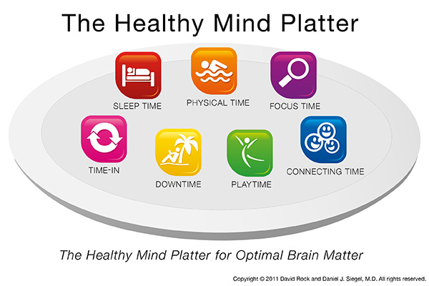 | Seven essential daily activities to keep our minds stimulated and maintain well-being  Focus Time When we closely focus on tasks in a goal-directed way, we take on challenges that make deep connections in the brain. E.G. specific school tasks, cooking a meal and even doing the house work with a sense of purpose  Play Time When we allow ourselves to be spontaneous or creative, playfully enjoying novel experiences, we help make new connections in the brain. E.G. creative activities like art, making something, listening to your favourite song  Connecting Time When we connect with other people - ideally in person with people in our homes OR virtually using our phones, emails etc we activate and reinforce the brain's relational circuitry – This can also happen when we take time to appreciate our connection to the natural world around us e.g. looking at beautiful pictures of the natural world, spending time looking out of our windows, listening to the bird song in the morning.  Physical Time When we move our bodies, aerobically if medically possible, we strengthen the brain in many ways. Do some physical activity each day e.g. Joe Wicks’ Workout, go for a walk if possible (respecting social distancing)  Time In When we quietly reflect internally, focusing on sensations, images, feelings and thoughts, we help our brains to form connections. E.G. do a mindfulness practice e.g. focusing on your breath, checking in with yourself “how am I feeling today” “what thoughts are on my mind”  Down Time When we are non-focused, without any specific goal, and let our mind wander or simply relax, we help the brain recharge. Where possible protect at least 10 minutes a day to just be  Sleep Time When we give the brain the rest it needs, we consolidate learning and recover from the experiences of the day. Try to maintain good sleep routines, keep the same bedtimes (children and adults), don’t read / watch the news before preparing to sleep and limit screen time at least an hour before bed.  It is important for both you and your child to keep in touch with family and friends, particularly during this time of social distancing and self-isolation. Where possible find ways to connect with friends and family virtually. This can reassure your child that their loved ones are safe and well and provides some normality during this difficult time.

Practicing wellbeing:
- Positive Emotion: ask your child something they are grateful for / connect with something you are grateful for
- Engagement: think of something your child is good at and help them to show this to you / complete a work activity with full awareness, attention and participation
- Relationships: Take the time to have a 1:1 bonding moment with your child / take a moment to connect with someone that you work with
- Meaning: Think with your child about the meaning of helping other people. Think about nurses and doctors and how they help.
- Accomplishments: Take a moment to compliment the child on something they have done well / think of something you are doing well at the moment

