Body Map Guidance

Body Maps should be used to document and illustrate visible signs of harm and physical injuries.

Always use a black pen (never a pencil) and do not use correction fluid or any other eraser.

Do not remove clothing for the purpose of the examination unless the injury site is freely available because of treatment.

*At no time should an individual teacher/member of staff or school take photographic evidence of any injuries or marks to a child’s person, the body map below should be used. Any concerns should be reported and recorded without delay to the appropriate safeguarding services, e.g. Social Care direct or child’s social worker if already an open case to social care.

When you notice an injury to a child, try to record the following information in respect of each mark identified e.g. red areas, swelling, bruising, cuts, lacerations and wounds, scalds and burns:

- Exact site of injury on the body, e.g. upper outer arm/left cheek.
- Size of injury - in appropriate centimetres or inches.
- Approximate shape of injury, e.g. round/square or straight line.
- Colour of injury - if more than one colour, say so.
- Is the skin broken?
- Is there any swelling at the site of the injury, or elsewhere?
- Is there a scab/any blistering/any bleeding?
- Is the injury clean or is there grit/fluff etc.?
- Is mobility restricted as a result of the injury?
- Does the site of the injury feel hot?
- Does the child feel hot?
- Does the child feel pain?
- Has the child’s body shape changed/are they holding themselves differently?

Importantly the date and time of the recording must be stated as well as the name and designation of the person making the record. Add any further comments as required.

Ensure First Aid is provided where required and record

A copy of the body map should be kept on the child’s concern/confidential file.

BODYMAP
(This must be completed at time of observation)

Name of Pupil: |  |  | Date of Birth:
Name of Staff: |  |  | Job title:
Date and time of observation:

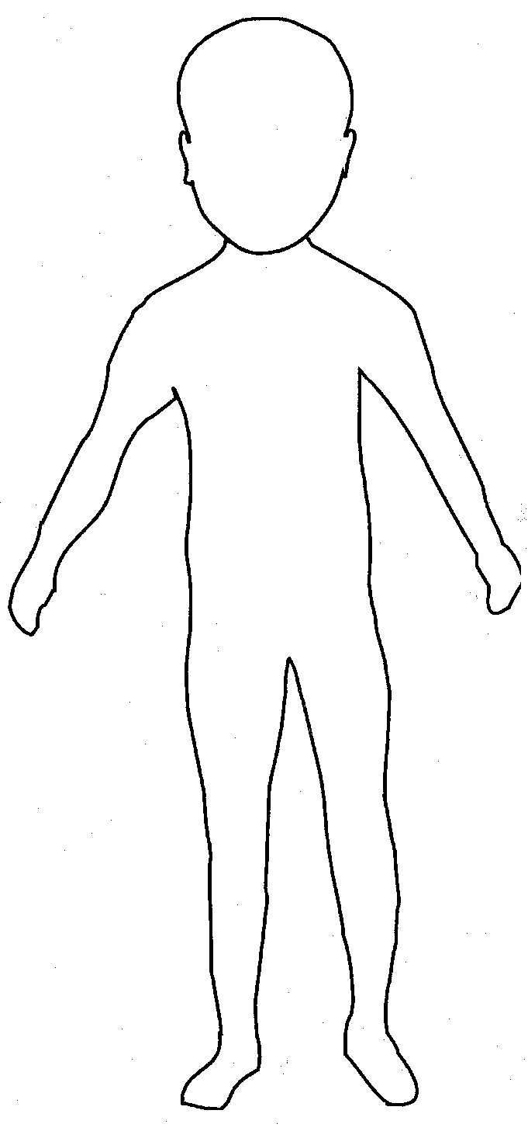 | 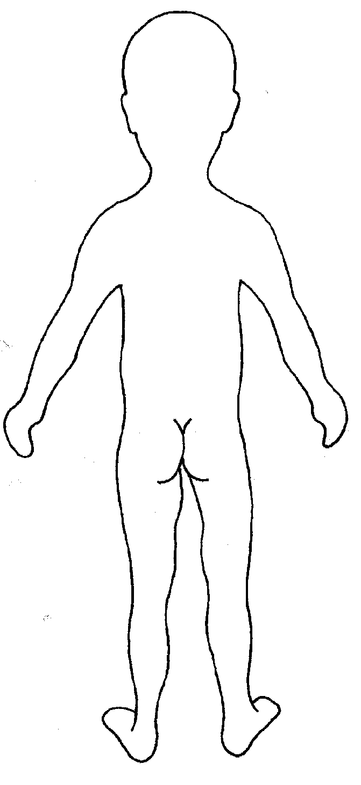

Name of pupil: |  |  | Date and time of observation:
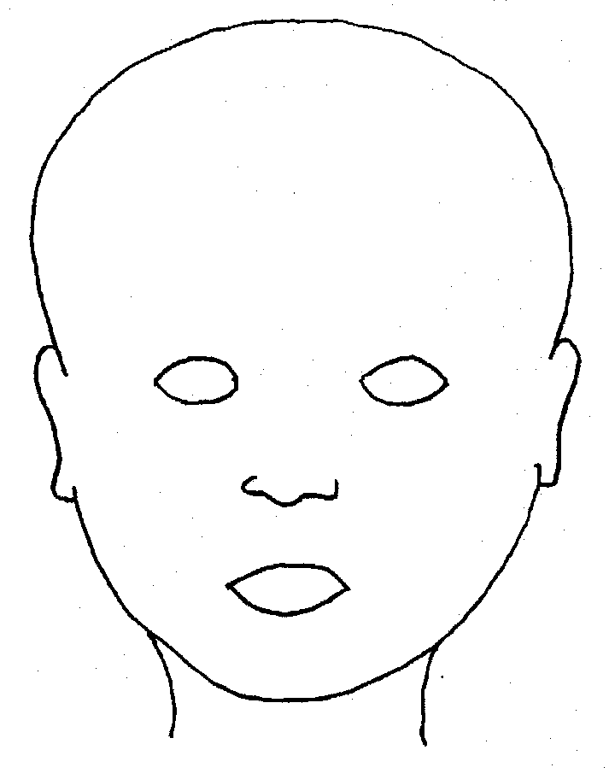 |  | 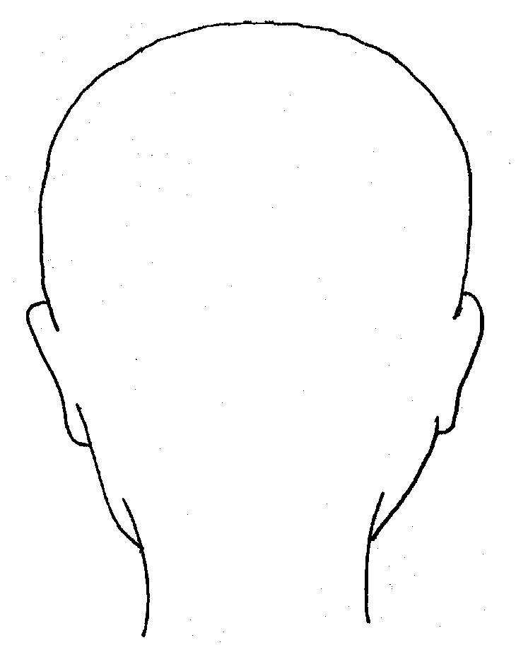
FRONT |  | BACK
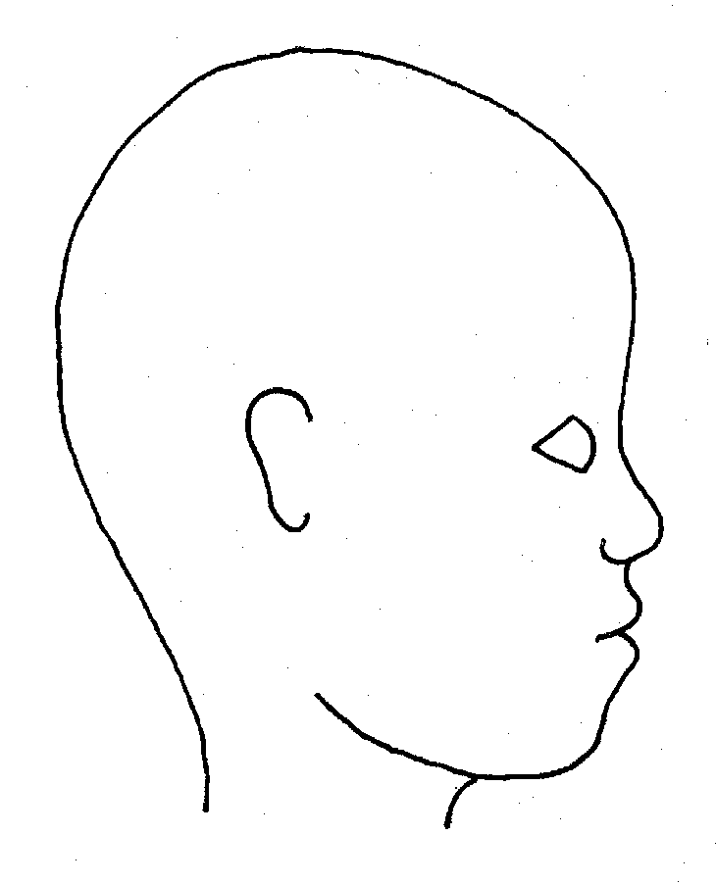 |  | 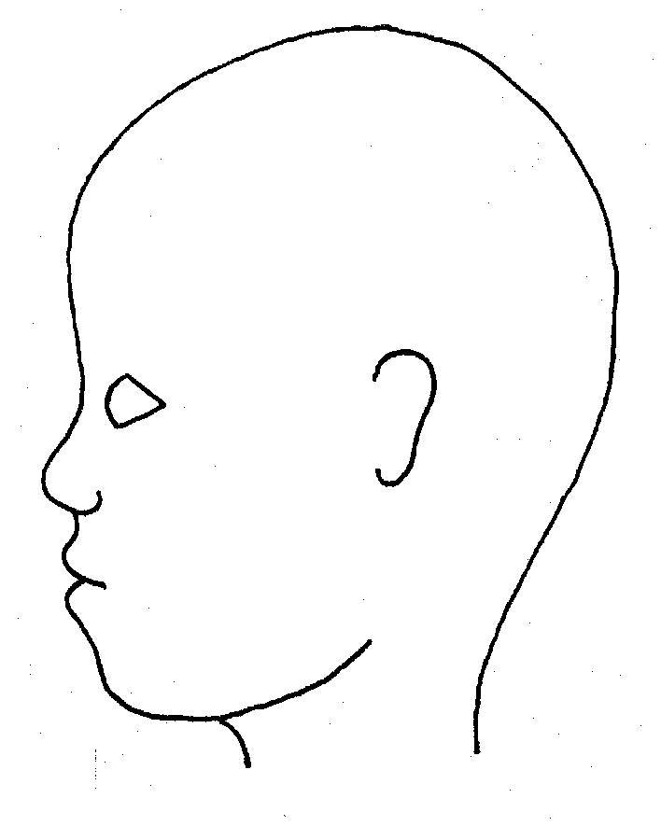
RIGHT |  | LEFT

Name of pupil: |  |  |  |  |  |  | Date and time of observation:
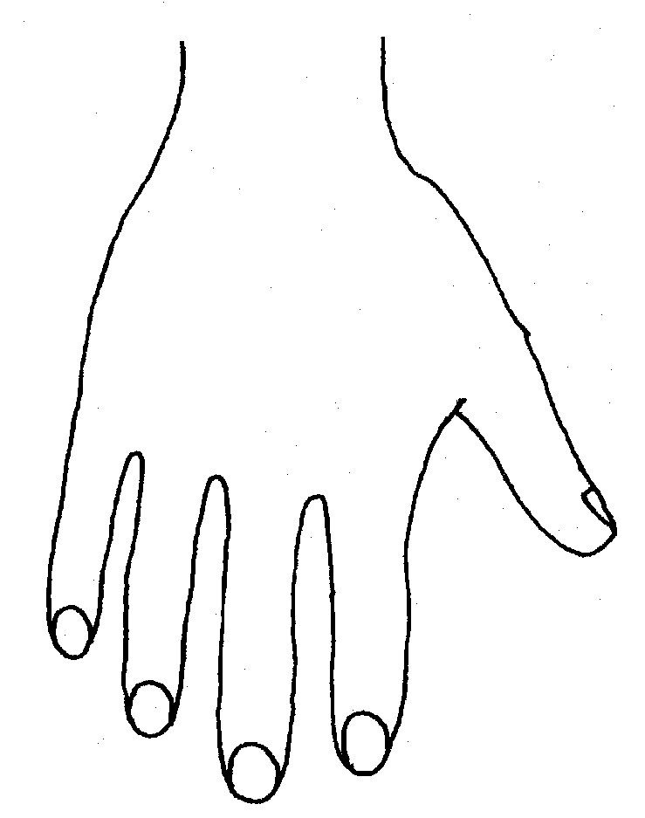 |  |  |  |  | 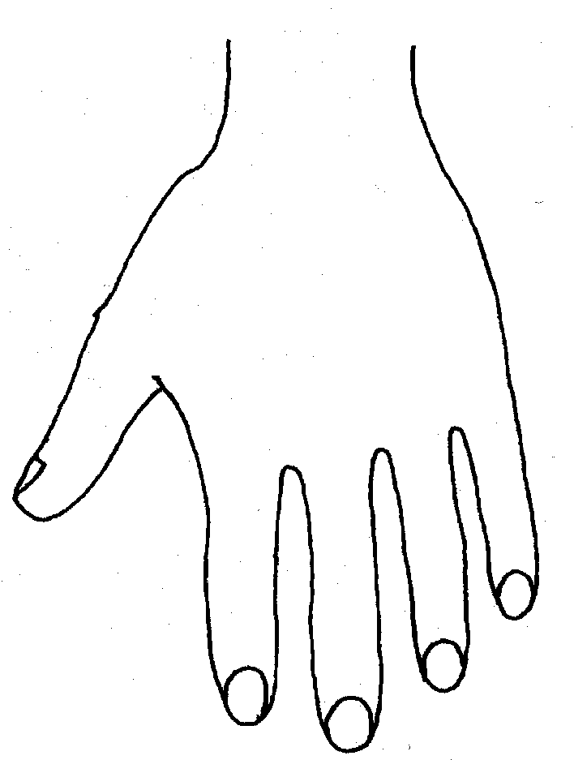
R |  |  |  |  | L
BACK
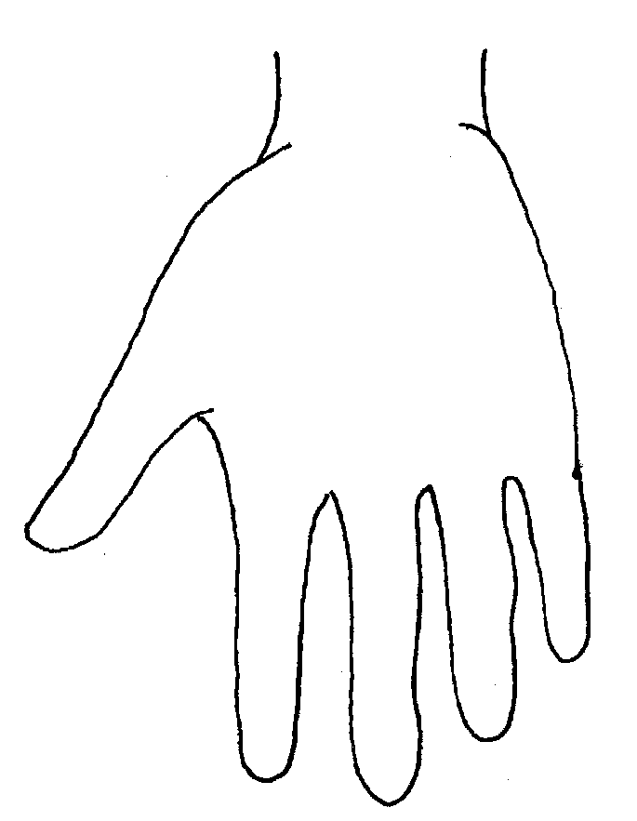 |  |  |  |  | 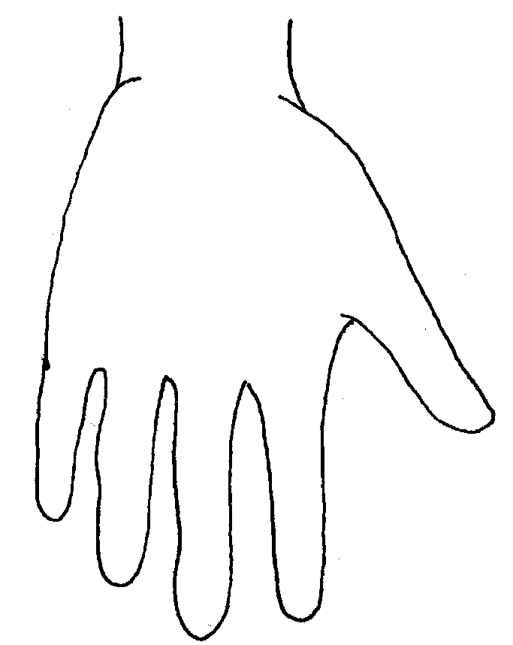
Name of pupil: |  |  |  |  |  |  | Date and time of observation:
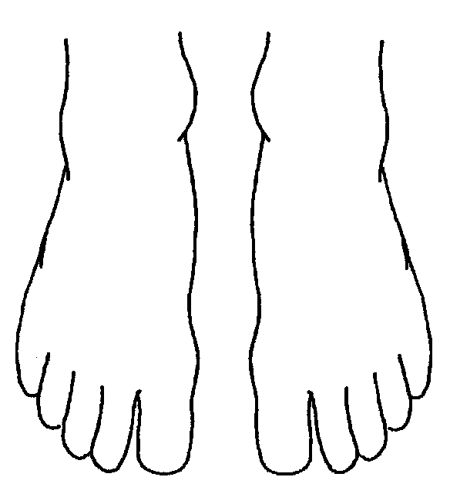 |  |  |  |  |  | 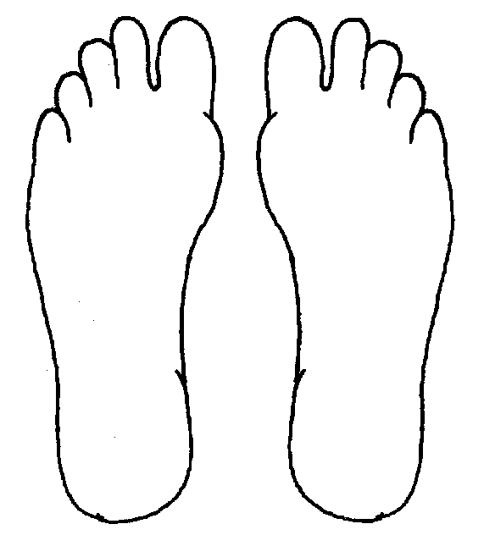
R | TOP |  |  | L |  | R |  | BOTTOM |  |  |  | L
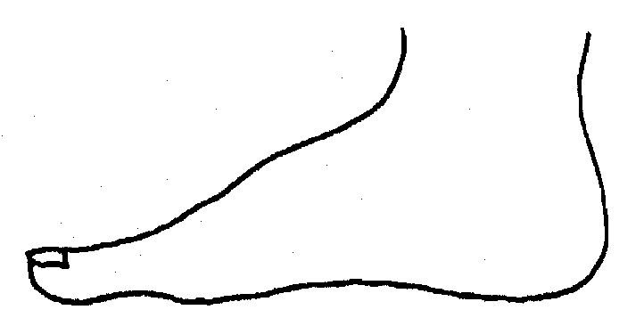
R |  |  |  |  |  | L
INNER
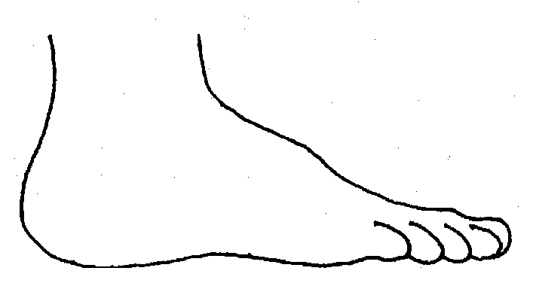 |  |  |  |  |  | 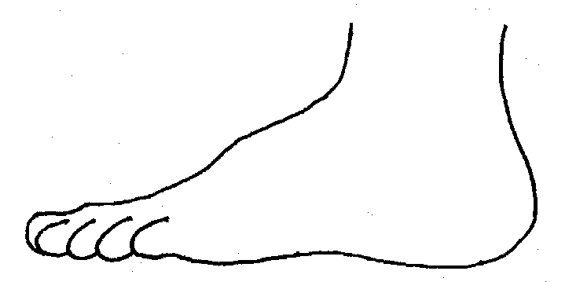
R |  |  |  |  |  | L
OUTER
Printed Name, Signature and Job title of staff:

