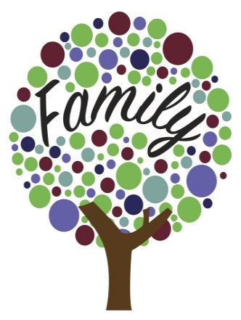
Community Team Around the Family
Closure and Evaluation
We want all children in Oxfordshire to have the best start in life, to enable them to reach their full potential. Sometimes children and families need additional support to achieve this.

The Team Around the Family (TAF) Closure and Evaluation form gives families the opportunity to feedback on how the TAF process has been for them. It helps celebrate success, recognise effort and highlight positive change. It helps review and improve the TAF process for other families.

This form should be filled in when a TAF is closing.

Family Background and Information

Date assessment started:

Family Details
Names of children
Names of parents/carers
Names of other significant adults
This helps us

Lead professional
Name |  | Role
Agency/ Organisation |  | Email
Telephone  Number |  | Address

Services which have provided support
Name | Role/Service | Support provided | Start date | End date
Additional Information:

This Meeting

Meeting details
Date of meeting | Venue of meeting
Who was present | Who was not present (apologies)

Outcomes

What were the desired outcomes of the EHA/TAF and have these outcomes been achieved?
Desired outcome | Achieved? (Fully, Partially, Not) | Comments
Additional Information

What have been the main changes for your family?

Which of the following statements are true? (Answer Yes/ No/ NA)
Any concerns about crime/ASB have been addressed
School attendance is 90% or more for all children
The case is stepping down (i.e. the TAF is closing)
Parent(s)/ Carer(s) are engaged in work or training, or have taken steps to improve work readiness
Young people aged 16-19 (16-25 with SEND) are engaged in education, employment or training
Any concerns in respect of Domestic Abuse have been addressed
Family members are appropriately addressing their physical and emotional health and well-being
You can include more statements here if needed.

Are there any things which still need to change?
If so what is the plan?

Are there any achievements that need celebrating?
If so, how will they be recognised?
E
Completing a TAF Closure and Evaluation form along with the final TAF paperwork to your area Locality and Community Support Service. Either by post or email:
Please send copies of your completed documents to your local Locality and Community Support Service. North: LCSS.North@oxfordshire.gov.uk South: LCSS.South@oxfordshire.gov.uk Central: LCSS.Central@oxfordshire.gov.uk
The Early Help Assessment and Team Around the Family Processes are vital components of ensuring that Children and Families get the right support at the right time. This is sponsored by all partners making up the OSCB.
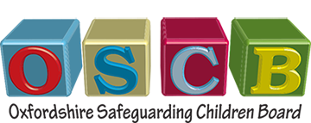

Evaluation
This sheet can be filled in by parents/family members and professionals separately/anonymously as needed – just provide them with this page.

Your details
If you’re a family member are you… | Parent |  | If you’re a professional working with the family, what is your role?
 | Child
 | Other (please say)
Your name (optional) |  |  | Contact details (optional)

Evaluation questions
Was the EHA/TAF process helpful? | Not at all | Yes, a bit | Yes, a lot
Did you feel listened to? | Not at all | Yes, a bit | Yes, a lot
Did you get the support needed? | Not at all | Yes, a bit | Yes, a lot
Are things now better for you/your family? | Not at all | Yes, a bit | Yes, a lot
Would you recommend EHA/TAF to someone else? | Not at all | Yes, a bit | Yes, a lot

Is there anything else you want to say?

Please send this completed Closure and Evaluation form along with the final TAF paperwork to your area Locality and Community Support Service, either by post or email:

LCSS North  Samuelson House  Tramway Rd  Banbury OX16 5AU  LCSS.North@oxfordshire.gov.uk | LCSS Central  Knights Court  Between Towns Road,  Oxford OX4 3LX  LCSS.Central@oxfordshire.gov.uk | LCSS South  Abbey House  Abbey Close  Abingdon OX14 3JD  LCSS.South@oxfordshire.gov.uk

Please send copies of your completed documents to your local Locality and Community Support Service. North: LCSS.North@oxfordshire.gov.uk South: LCSS.South@oxfordshire.gov.uk Central: LCSS.Central@oxfordshire.gov.uk
The Early Help Assessment and Team Around the Family Processes are vital components of ensuring that Children and Families get the right support at the right time. This is sponsored by all partners making up the OSCB.

