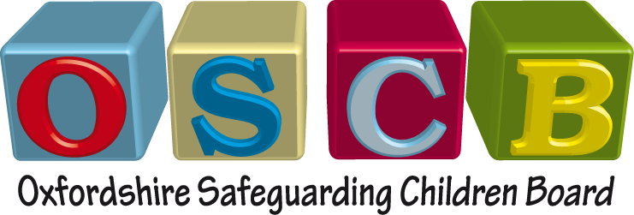

Key learning points from the OSCB’s most recent
Serious Case Reviews (SCRs) undertaken are:

- The role of the fathers in the family system together with communication with and involvement of fathers and male carers;

- The need for curiosity about family history, relationships and current circumstances that moves beyond reliance on self-reported information;

- More challenges are faced by professionals working with vulnerable families where neglect is an embedded issue;

- The impact of the parent’s mental health problems on the safety and wellbeing of children;

- Understanding of substance misuse and interventions, the changing levels of risk, and the impact on the child;

- Normalising and misinterpreting behaviour - linked to Special Educational Needs;

- Identifying the increased safeguarding risks for children with learning disabilities and Special Educational Needs;

- Identification of physical abuse and following safeguarding processes thoroughly;

- Multi-agency work must be well co-ordinated in order to share planning and to better understand what is happening to the child. Effective risk management requires systematic planning across the multi-agency partnership;

- The capacity of adolescents to protect themselves can be overestimated and a tendency to view teenagers as adults rather than children can mean that proactive steps to protect them are not always taken.

