What is my home like for me?

Simpler version for Younger Children and those with Learning Difficulties or Disability

This is a reflective tool to help with recording the state of the home. It is intended to support children to share their thoughts/feelings.

- The diagram helps children explore their thoughts and feelings around the place they live
- Workers may find it helps to use an actual picture of the child/family’s home
- The questions included are examples and should be edited before use and to highlight any concerns

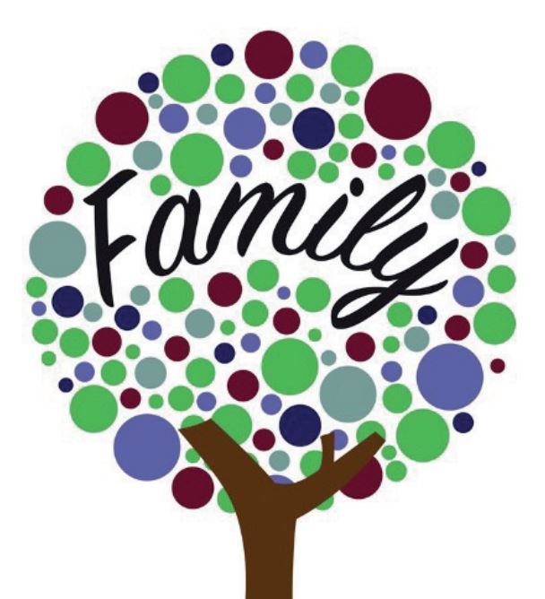
What is my home like for me? (blank)

What is my home like for me? (with prompts)

What is the best place at home?

What could be better?

What makes me sad?

What makes me happy?

What is my home like for me? (blank to fill in)

