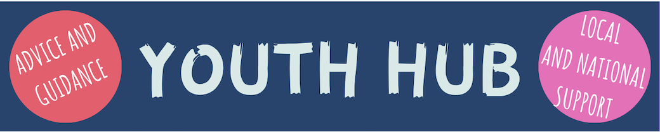
The role of the Herefordshire Safeguarding Children Partnership is to make sure agencies are working together to safeguard children and young people.
This part of the site, the ‘Youth Hub’ is for all young people aged 11-18 in Herefordshire and puts together lots of information, help and advice on topics that really matter to young people and will help to keep you safe. Some of it can be sensitive, so look out for the trigger warnings above. Remember, if you are concerned about anything, it’s always best to tell a trusted adult, and if you need immediate help there’s the number for Childline at the bottom of every page. If you need to report a concern, there’s also the ‘Concerned about a child’ box at the top of each page, plus a ‘Leave Page’ function if you need to leave the page quickly.
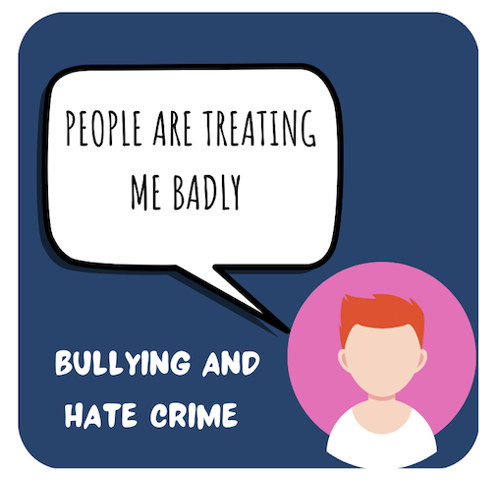
The boxes below highlight the areas young people told us they wanted extra support with. Click on each one to show you helpful links to more information, local and national support. Whatever your concern, you’re not alone and there are lots of agencies out there to help.
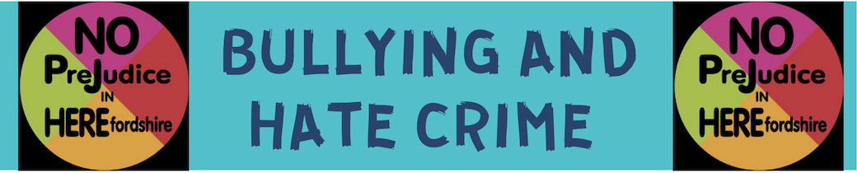

It’s never right for someone to treat you badly or make you feel uncomfortable whether at school, in the community or at home (see the section on Safety at Home for more on this one). We all have a right to feel safe and where there is bullying or Hate Crimes committed against us or others, it’s important that we get help and support. Look at the links below to find out more

