Multi-Agency Guidance for professionals
Delegation portal
The delegation portal will enable OCC to request information about a child/young person that external agencies are working with by sharing their contributions in the Multi-Agency Chronology. It allows the professionals to communicate via a secure portal by completing forms and attaching documents. Where possible the information has been pre-populated from the data that is already in the system, saving the professionals time in completing the forms. It also allows the consolidation of forms for siblings, so only one form is required per family.
When a delegated section of a form is sent to the agency, they will receive an email. There are no details of the child within the email, the agency will need to log in to the portal to view the details of which child this relates to.
The agencies need to be set up in LCS as professionals, but will not need an account
Delegation portal process
- When the delegated form is sent to the professional an email is sent to the professional.

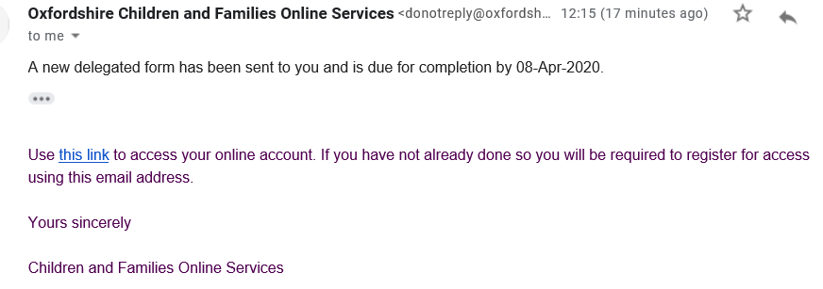

- They will need to either login or register to access the form. Click on the link within the email to access the portal. If it is the first time using it, click on the link to the right: Register for new account
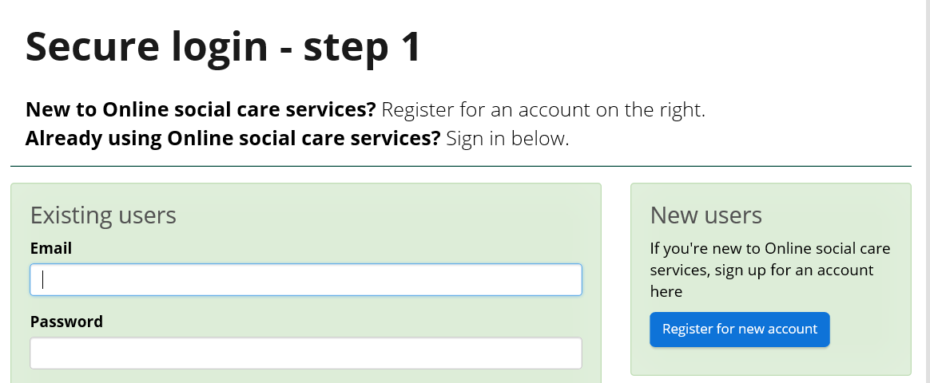

- Enter your Forename and Surname and click on Next
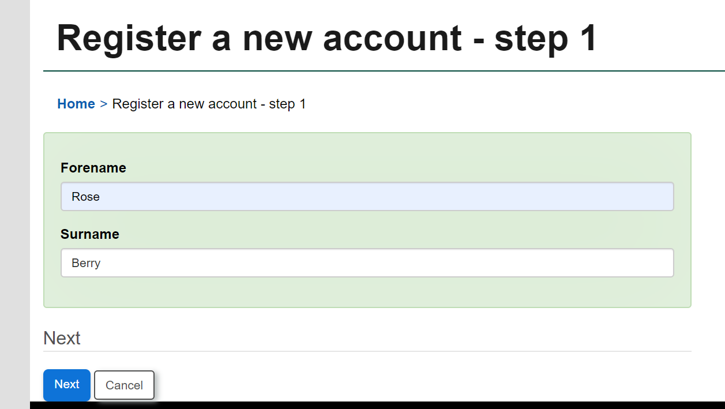

- Enter your email address and create a password, then click on next

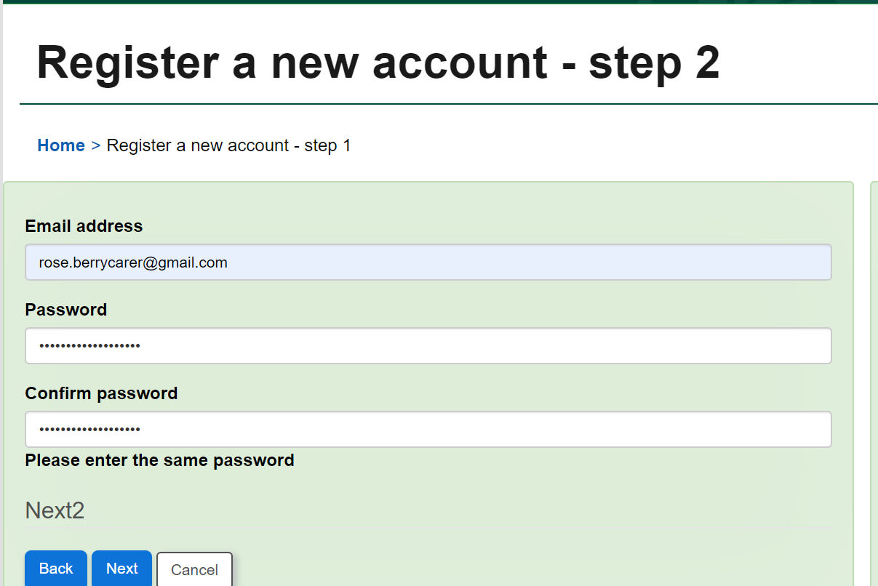

- An email is sent with a verification code, copy and paste this code and click on next.
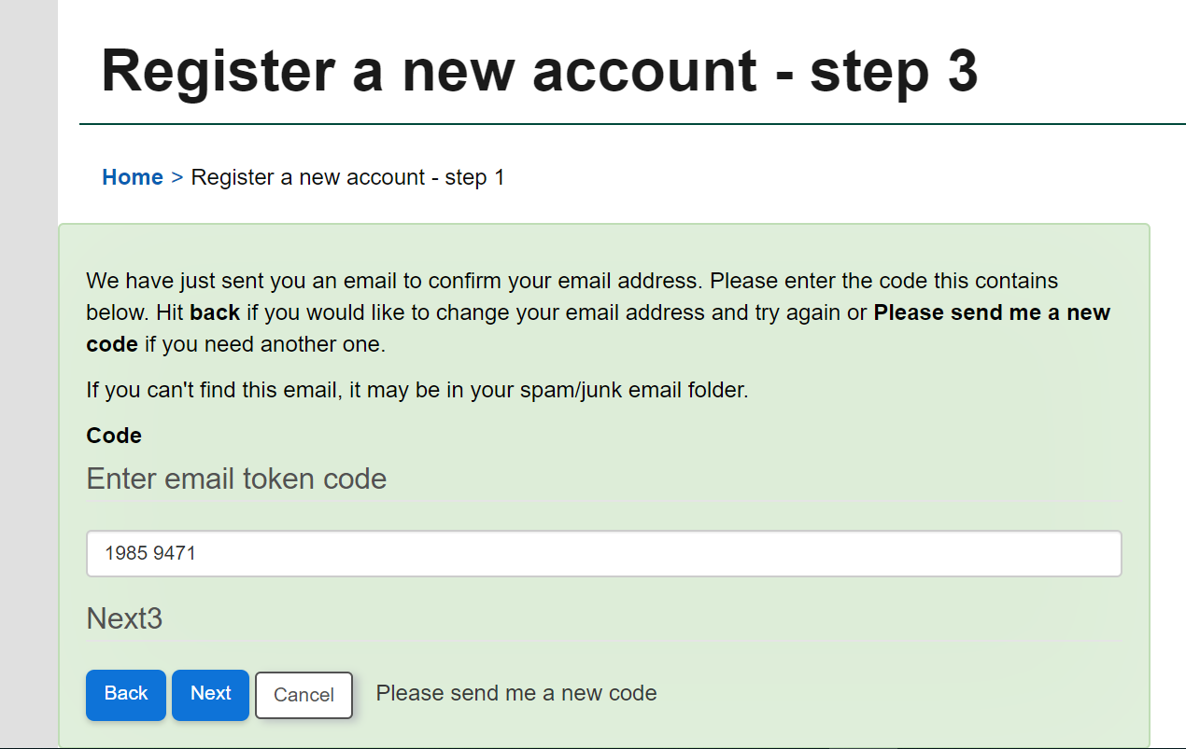

- You will then be in your account and can see the details of the form that was delegated to you to contribute and the child it relates to.
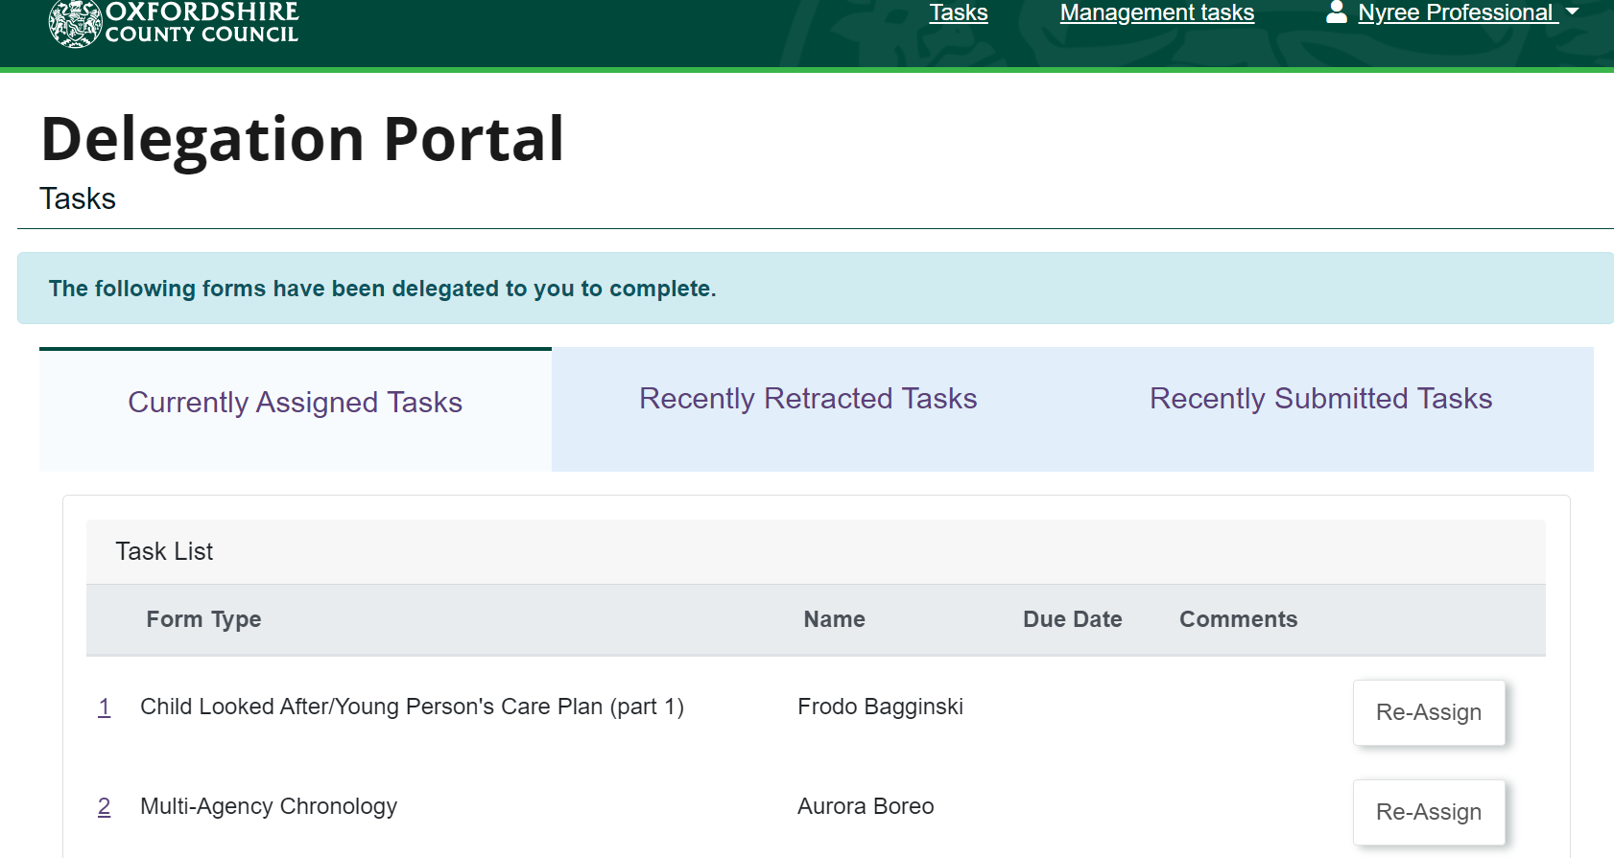
- Click on the name of the child to access the form. Any mandatory fields are marked with an *, and this will need to be completed before submitting the form.
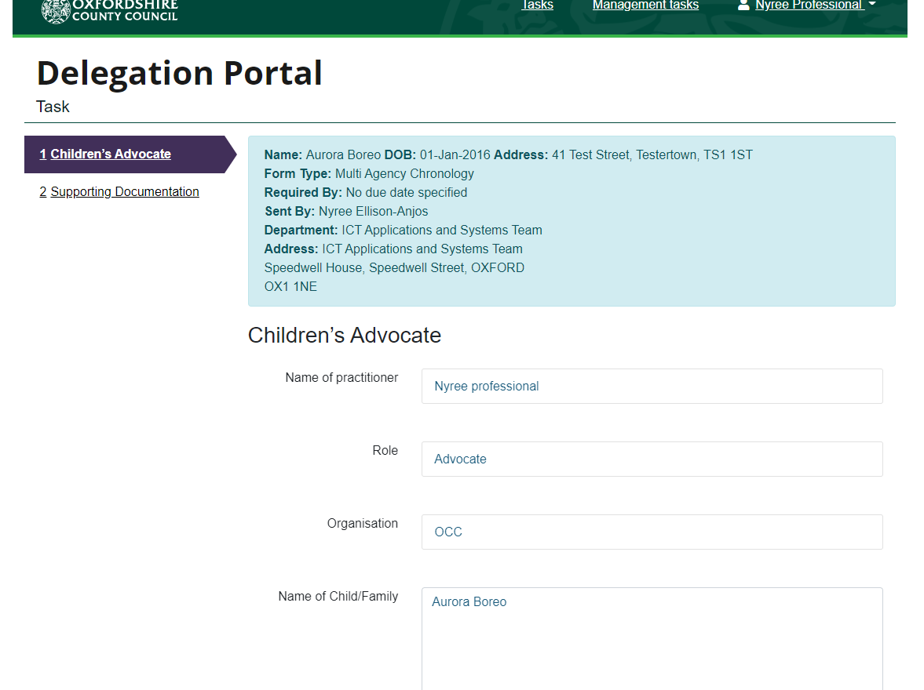
- The Chronology is in a table format, and you can add as many rows as needed.
  - Enter the details in the fields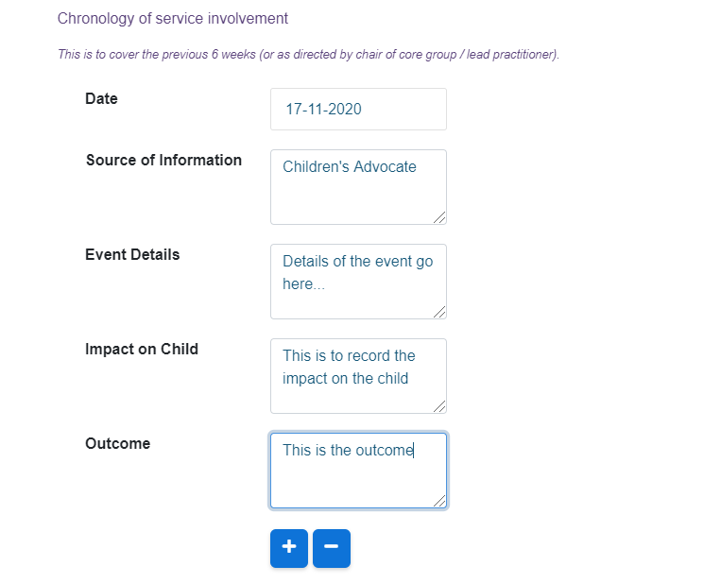
  - To add another row, click on the sign at the bottom of the table, this will add another row to the table.
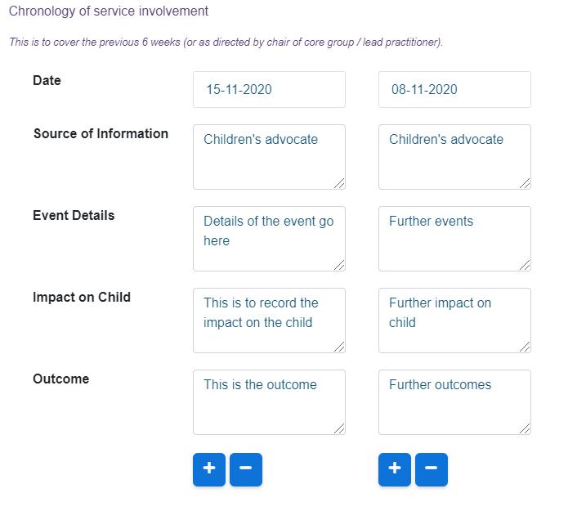

- At the bottom of the screen you have a next and previous button to navigate through the form. There is also a print, PDF, close, save and submit contribution buttons.

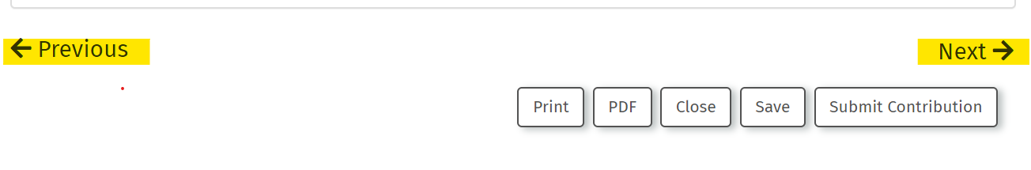
This will allow the agencies to download the Multi-agency Chronology form and save it.
- Click on “Next” at the bottom of the page or click on the link “Supporting Documentation” on the top left where you can upload documents.
  - Click on Choose File – this will open your File management, where you can select the file to upload.
  - Click on the file and click on open – you will see the document listed, and a remove button beside it if you need to remove it.
  - If you need to upload more documents, click on Choose File again and follow the above steps.

- When the form is completed click on “submit contribution”, and the form will be sent to the Children’s social care system.

Automatic replies
In the portal you are can set an automatic reply, which you can use when you are on leave or out of the office. It will notify the user that is delegating the form from LCS, so they can send it to someone else if required.
From the top right of the screen, when you click on your name you will see a menu with three options:
Update Account – this will allow you to change your profile details and change your password.
Automatic replies – This is where you can set the automatic reply. Details below
Logout – Always ensure you use the logout link to safely close down the portal.

Adding an automatic reply
- Click on the link “Automatic Replies”
- Click on the
- Enter the Start and End date and enter a message e.g. I am out of the office.
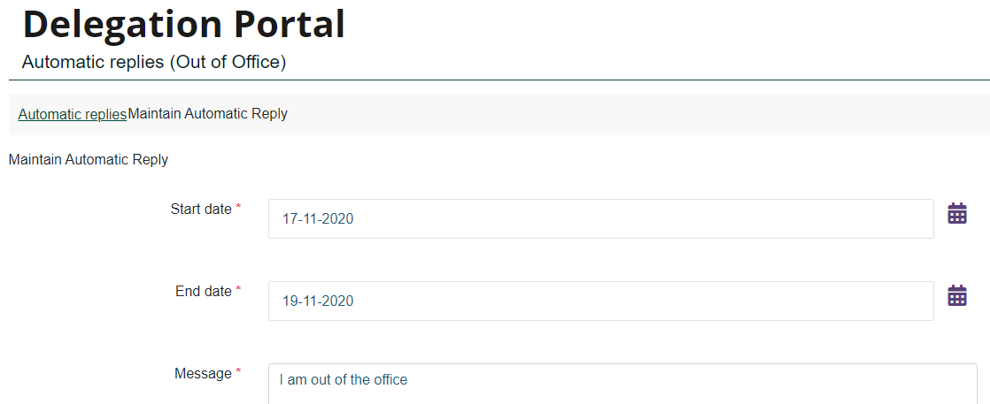
- Click on Save
The message will be displayed in the Children’s Social Care system until the end date.
When you are on your tasks page the following message is displayed:
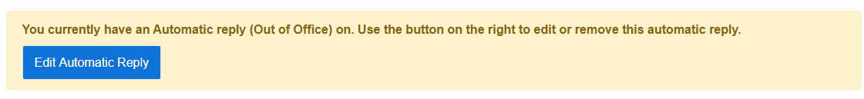
By clicking on “Edit Automatic Reply” it will take you to the automatic replies screen, where you update the out of office.

